Login and Registration Project

Login and Registration is a User Friendly Interface with an Interactive Login and Registration Form. Here Users can have fun by Adding users to the Database and Play Around with the records. Below are some Features.

Features

- Register as many user as needed
- Highly secured Form Validation for Registation and Login
- If you're logged in then its not possible to delete your own Record from Database
- During Registration Checks if Email and Username already Exist and Throws Error if True
- During Registration Checks if the Password has a 1 Upper case, 1Lower Case and 1 Number.
- Allows you to Edit the User Records After Login
- With Pagination we can load Record more Efficiently
- After Logging in Displays Logged in Users Name on the Top Along with His Joining Date
- After Logging in Displays Current Date and Time and Also the Logged users 'Username' and 'Email'
- After Logging in Users can Contact us with their Queries with a User Friendly Form
How to Install it on a Local Server without any Developers Aid!!

These installation steps are written keeping in mind that the user has no prior knowledge of Project Installation on the Local Server(i.e., Computer ) using a Tool called XAMPP. Please follow the steps has given below.

Download XAMPP

- Go to https://www.google.com and Type XAMPP
- Go to appropriate link and Download the XAMPP Server
- Double click and Install it
- After Installation, Run XAMPP Play Around and Understand the Interface
- Refer the Below Image..

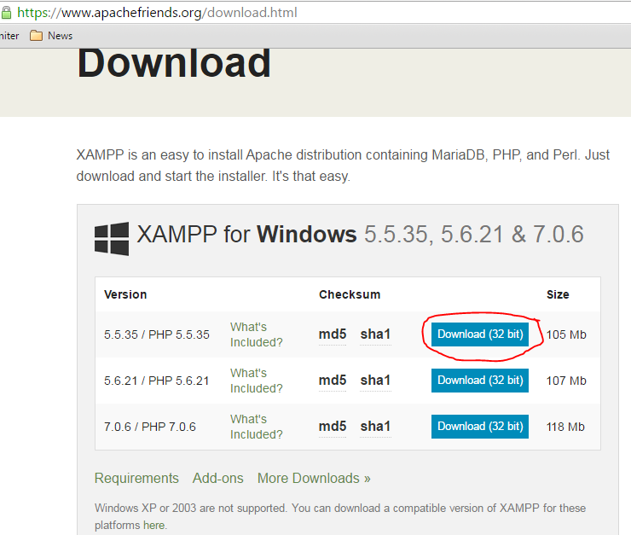

Copying the Project File To Local Directory

- Make Sure you close the XAMPP before continuing.
- Unzip the Project File (loginreg_project.zip) you received and Copy that to clipbard (Right click on the Project folder click Copy)
- Go to 'C:\XAMPP\htdocs\' Folder and paste the project folder ((loginreg_project) in htdocs folder. That is the folder from where XAMPP will know the Project after Typing 'Localhost' in a Browser (Refer Below Image)

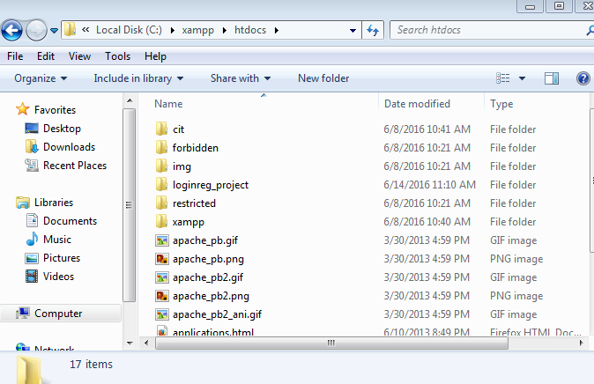

Starting The Local Server from XAMPP

- Open XAMPP, Click start on Apache, This is a Local Server that will be Created on the System and This is needed to Run our Project
- Now Click Start on MySQL and the Local Database will be started from where you can create Database and store data securely
- Run Any Browser (Chrome, Mozilla) and in the URL bar Type 'localhost' check Something Pops with XAMPP Written on it. If it Shows then the Server is Running Successfully.(Refer the Below Image)

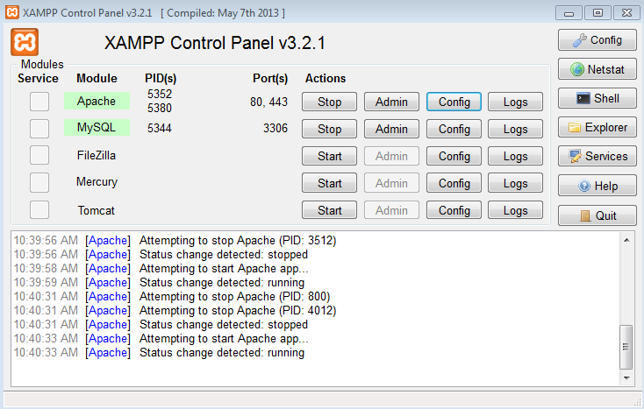

Copying the Project Database to Local Database(PhpMyAdmin)

- Don't close XAMPP, let that be running.
- Now open the Browser and in the URL field type 'localhost/phpmyadmin'. It should bring something like in image below
- Now click on Import and there click on browse. One window will pop up, then go to 'C:\XAMPP\htdocs\loginreg_project/database' and select 'loginreg_project.sql'. Once selected do not change any settings there, just click go and the project database will be loaded.

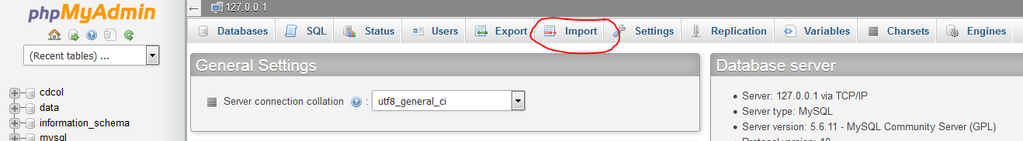

It's Time to Run and Test the Application

Goto 'localhost/loginreg_project' and Explore the Application. Below are some Images for Reference.
